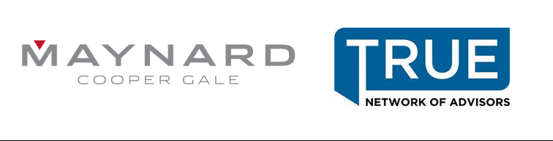
Certification Information for
COVID-19 Resources Webinar Series:
Return to Work Considerations & Updated Benefits Guidance
Matthew Stiles and Matthew Cannova
June 2, 2020

HRCI Approval
Activity ID: 523718
Title: COVID-19 Resources Webinar Series: Return to Work Considerations & Updated Benefits Guidance, Part II
Start Date: 6/2/2020
End Date: 6/2/2020
Credit Hours: 1
Specified Credit Hours: HR (General)
This activity has been approved for 1 (General) recertification credit hour(s) toward aPHR™, PHR®, PHRca®, SPHR®, GPHR®, PHRi™ and SPHRi™ recertification through HR Certification Institute® (HRCI®). Please make note of the activity ID number on your recertification application form. For more information about certification or recertification, please visit the HR Certification Institute website at www.hrci.org.
SHRM Approval
Activity ID: 20-DVYXR
Title: COVID-19 Resources Webinar Series: Return to Work Considerations & Updated Benefits Guidance, Part II
Start Date: 6/2/2020
End Date: 6/2/2020
PDCs: 1
Maynard, Cooper & Gale, P.C. is recognized by SHRM to offer Professional Development Credits (PDCs) for the SHRM-CPSM or SHRM-SCPSM. This program is valid for 1 PDC(s) for the SHRM-CPSM or SHRM-SCPSM. For more information about certification or recertification, please visit www.shrmcertification.org.

